Instructions
- In this lab assignment, you will solve problem(s) based on what you have learnt in objects and classes.
- There are 4 queries in this assignment.
- This evaluation instrument, if submitted after due date, will not be evaluated, and a score of zero will be awarded.
- Email/paper/other modes of submissions will not be accepted.
- Upload a pdf version of this document.

Due Time: 2 hours after assigning.

Submitting this Assignment

Paste your code and snapshot of output after the question, save the document You will submit (upload) this assignment in LMS moodle. Paste your code and snapshot of output after the question, save and upload the document.

Problem:
Basic Python Programming understanding:
1. Write a program to print the Fibonacci series up to N terms.
2. Write a program to check whether a number is positive, negative, or zero.
3. Write a Python program to implement the A* search algorithm to find the shortest path from node A to node G.
4. Smart Street Light Agent
Write a Python program to implement a Simple Reflex Agent for a street light. If it is dark, the agent should turn the light ON; if it is bright, the agent should turn the light OFF. Display the sequence of perceptions and actions.

Query:

Output:

Query 1:
def print_fibonacci(n):
if n <= 0:
print("Please enter a positive integer.")
return []
a, b = 0, 1
fib_series = []
for _ in range(n):
fib_series.append(a)
a, b = b, a + b
return fib_series

n_terms = 10
result = print_fibonacci(n_terms)
print(f"Fibonacci series up to {n_terms} terms:")
print(result)
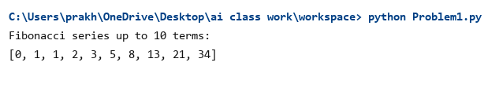
Output:

Query 2:
def check_number(num):
if num > 0:
return "Positive"
elif num < 0:
return "Negative"
else:
return "Zero"

test_numbers = [15, -7, 0, 42.5, -18.2]
print("Number Classification Check:")
print("=" * 35)
for num in test_numbers:
result = check_number(num)
print(f"Number: {num:>6} -> {result}")
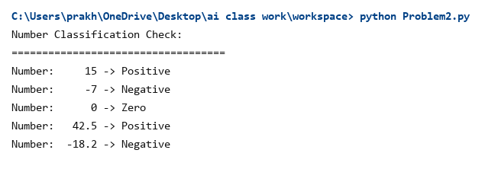
Output:

Query 3:
import heapq

def a_star_search(graph, heuristics, start, goal):
open_set = []
heapq.heappush(open_set, (0 + heuristics[start], 0, start, [start]))
visited = {}

while open_set:
f_score, g_score, current, path = heapq.heappop(open_set)

if current in visited and visited[current] <= g_score:
continue
visited[current] = g_score

if current == goal:
return path, g_score

for neighbor, weight in graph.get(current, []):
new_g = g_score + weight
new_f = new_g + heuristics[neighbor]
heapq.heappush(open_set, (new_f, new_g, neighbor, path + [neighbor]))

return None, float('inf')

graph = {
'A': [('B', 4), ('C', 2)],
'B': [('D', 5), ('E', 10)],
'C': [('E', 3), ('F', 8)],
'D': [('G', 11)],
'E': [('G', 4)],
'F': [('G', 5)],
'G': []
}

heuristics = {
'A': 10,
'B': 8,
'C': 5,
'D': 7,
'E': 3,
'F': 4,
'G': 0
}

start_node = 'A'
goal_node = 'G'
path, total_cost = a_star_search(graph, heuristics, start_node, goal_node)

print("A* Search Algorithm (Node A to Node G)")
print("=" * 45)
print(f"Start Node : {start_node}")
print(f"Goal Node : {goal_node}")
print(f"Shortest Path Found: {' -> '.join(path)}")
print(f"Total Path Cost : {total_cost}")
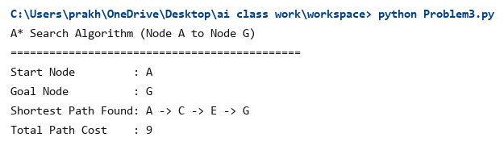
Output:
Query 4:
def street_light_agent(environment_light):
if environment_light == "Dark":
return "Light ON"
else:
return "Light OFF"

perceptions = ["Dark", "Dark", "Bright", "Dark", "Bright", "Bright"]
print("Smart Street Light Agent - Simple Reflex Agent")
print("=" * 45)
for i, perception in enumerate(perceptions):
action = street_light_agent(perception)
print(f"Step {i+1}: Perception = {perception} -> Action = {action}")

print()
print("Agent Details:")
print("Sensor : Light Sensor / LDR (detects ambient light)")
print("Actuator : Street Light Switch (ON/OFF)")
print("Agent Type : Simple Reflex Agent")
print("Environment: Fully Observable, Single-agent, Static")
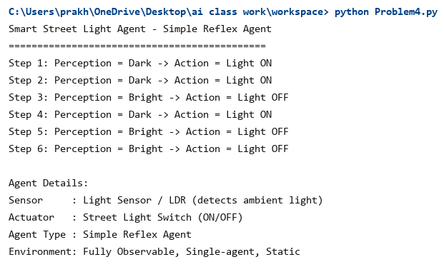
Output:

